PROJECT REPORT

TRACING THE GROWTH OF THE GLOBAL COMMUNITY : A POPULATION FORCASTING ANALYSIS

1. Introduction
   1. Overview

The world’s population is more than three times larger than it was in the mid-twentieth century. The global human population reached 8.0 billion in mid-November 2022 from an estimated 2.5 billion people in 1950, adding 1 billion people since 2010 and 2 billion since 1998. The world’s population is expected to increase by nearly 2 billion persons in the next 30 years, from the current 8 billion to 9.7 billion in 2050 and could peak at nearly 10.4 billion in the mid-2080s. This dramatic growth has been driven largely by increasing numbers of people surviving to reproductive age, the gradual increase in human lifespan, increasing urbanization, and accelerating migration. Major changes in fertility rate have accompanied this growth. These trends will have far-reaching implications for generations to come.

* 1. Purpose

Understanding the social, cultural, economic, and political processes that have impacted our society over time will help us better comprehend how the global community has developed. We can better comprehend the historical background of present events, spot trends and patterns, and foresee future changes by looking at how the global community has evolved.

We can better understand the diversity of human experience and see the connections that bind us by charting the development of the world community. It can stimulate cross-border cooperation and collaboration to address shared concerns, helping to cultivate a feeling of global citizenship.

Studying the expansion of the world community can also assist to foster peace, stability, and prosperity for everybody by influencing national and international policies and decision-making.

As people from many cultures and backgrounds come together to share ideas and expertise, it can also stimulate innovation and creativity.In general, studying the expansion of the international community can give us important new perspectives on the complexity and interdependence of our world, assisting us in creating a future that is more inclusive, equitable, and sustainable.

2 Problem definition and design thinking.

2.1 Empathy map

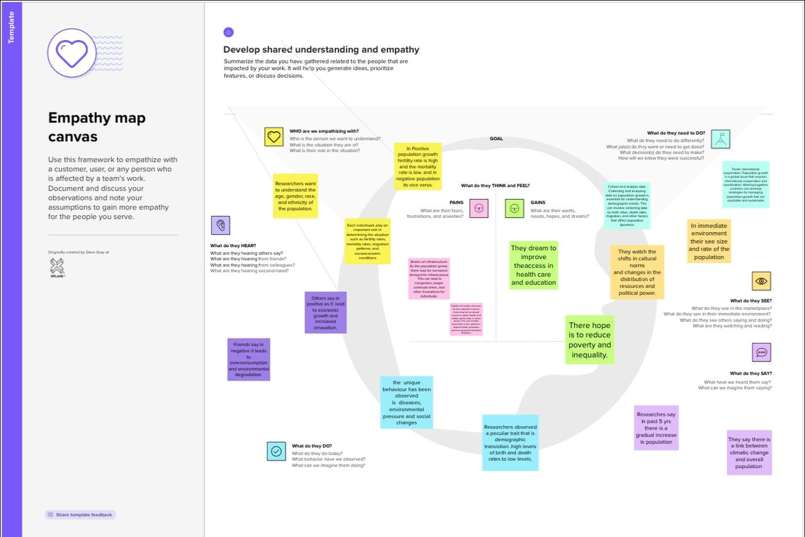

2.2 Ideation and Brainstorming Map

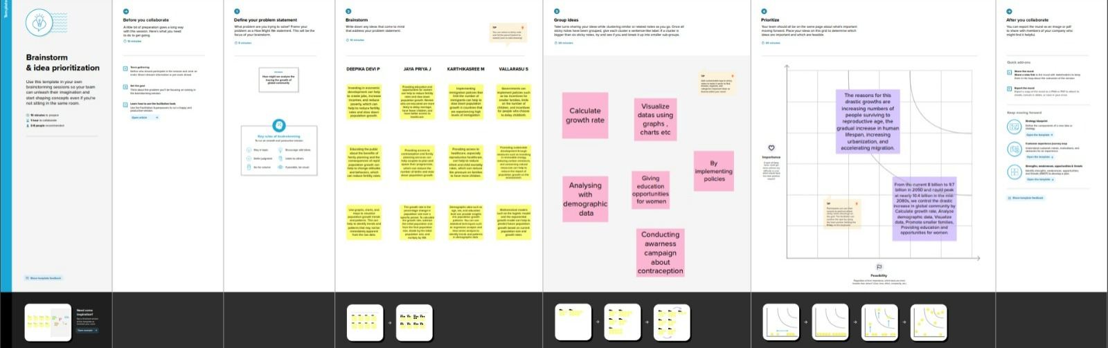

3 Result

Activity & Screenshot

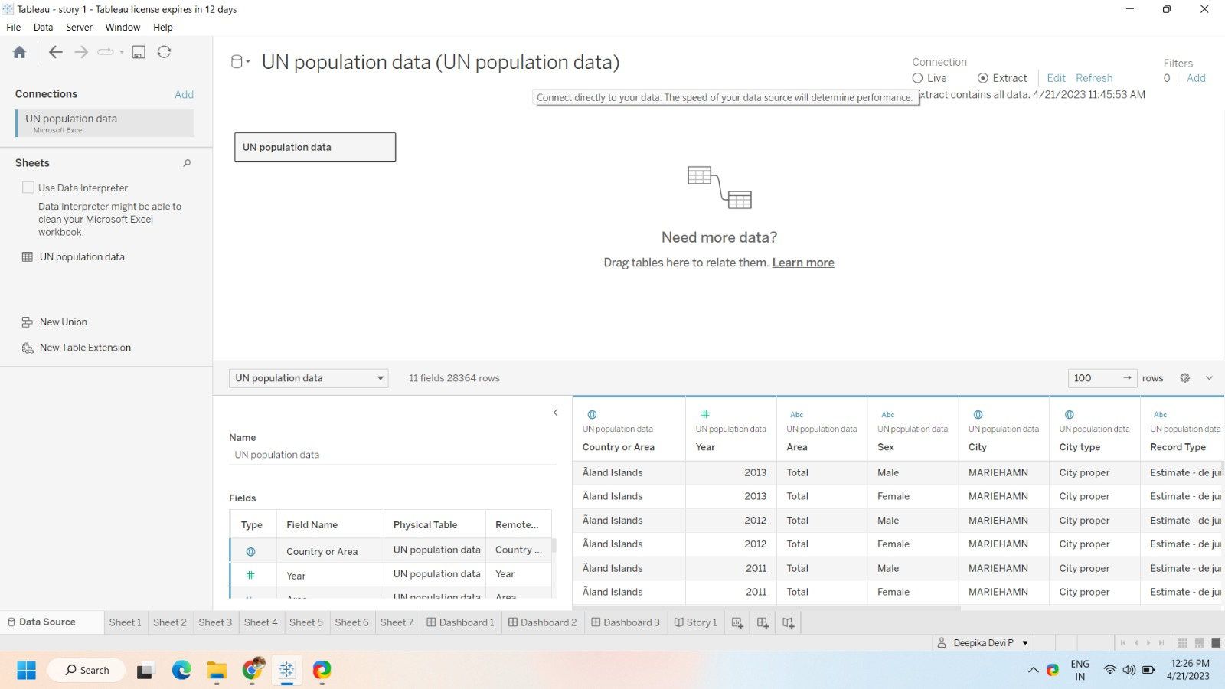

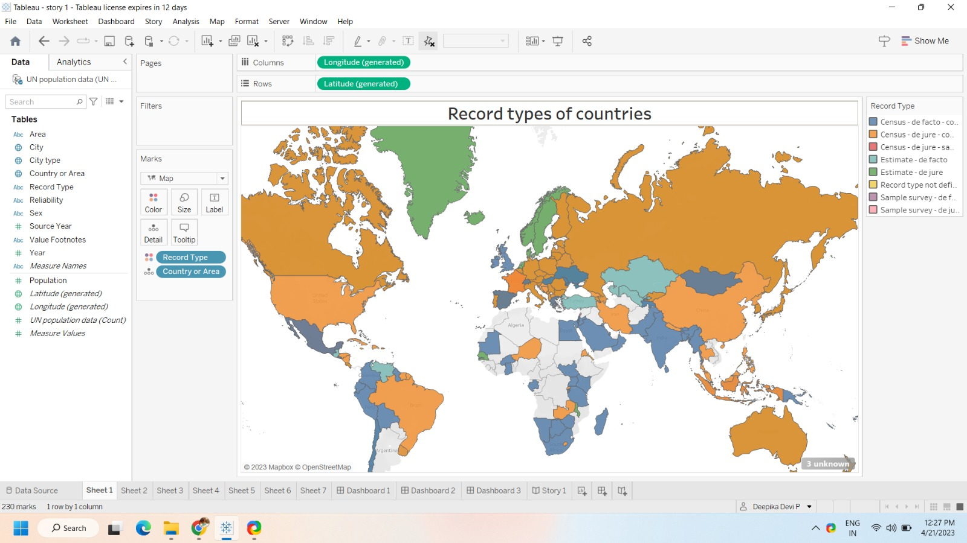

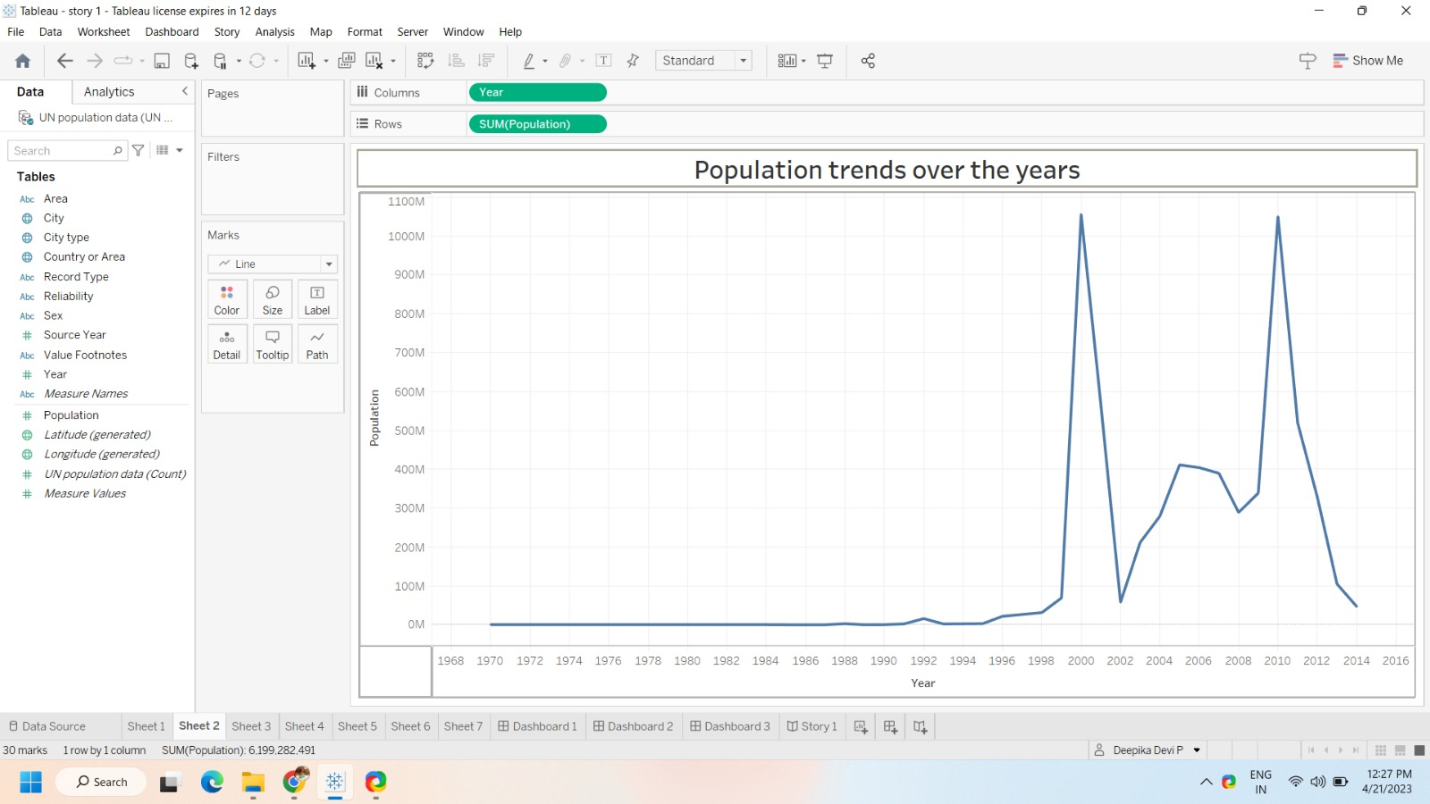

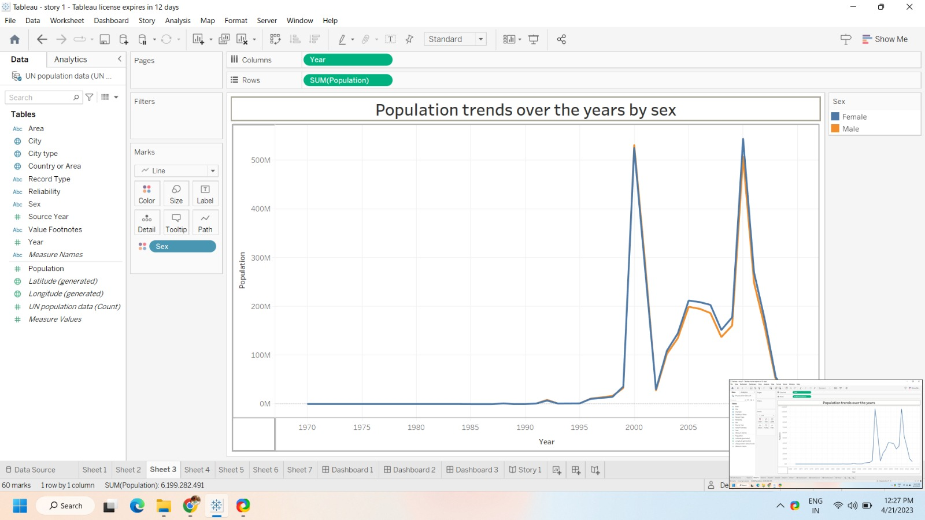

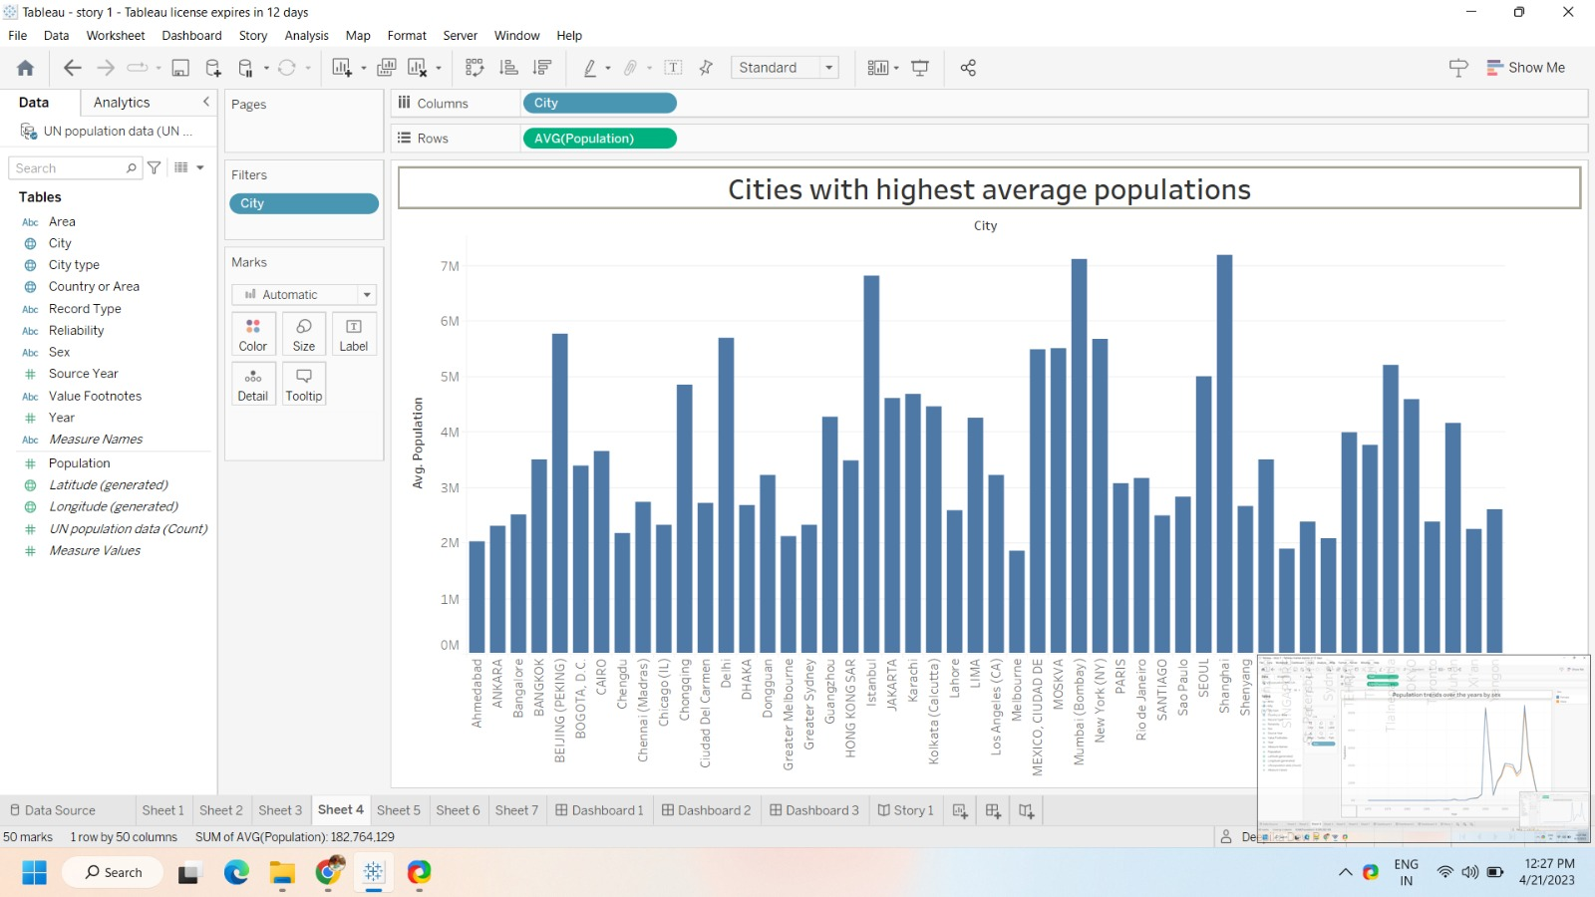

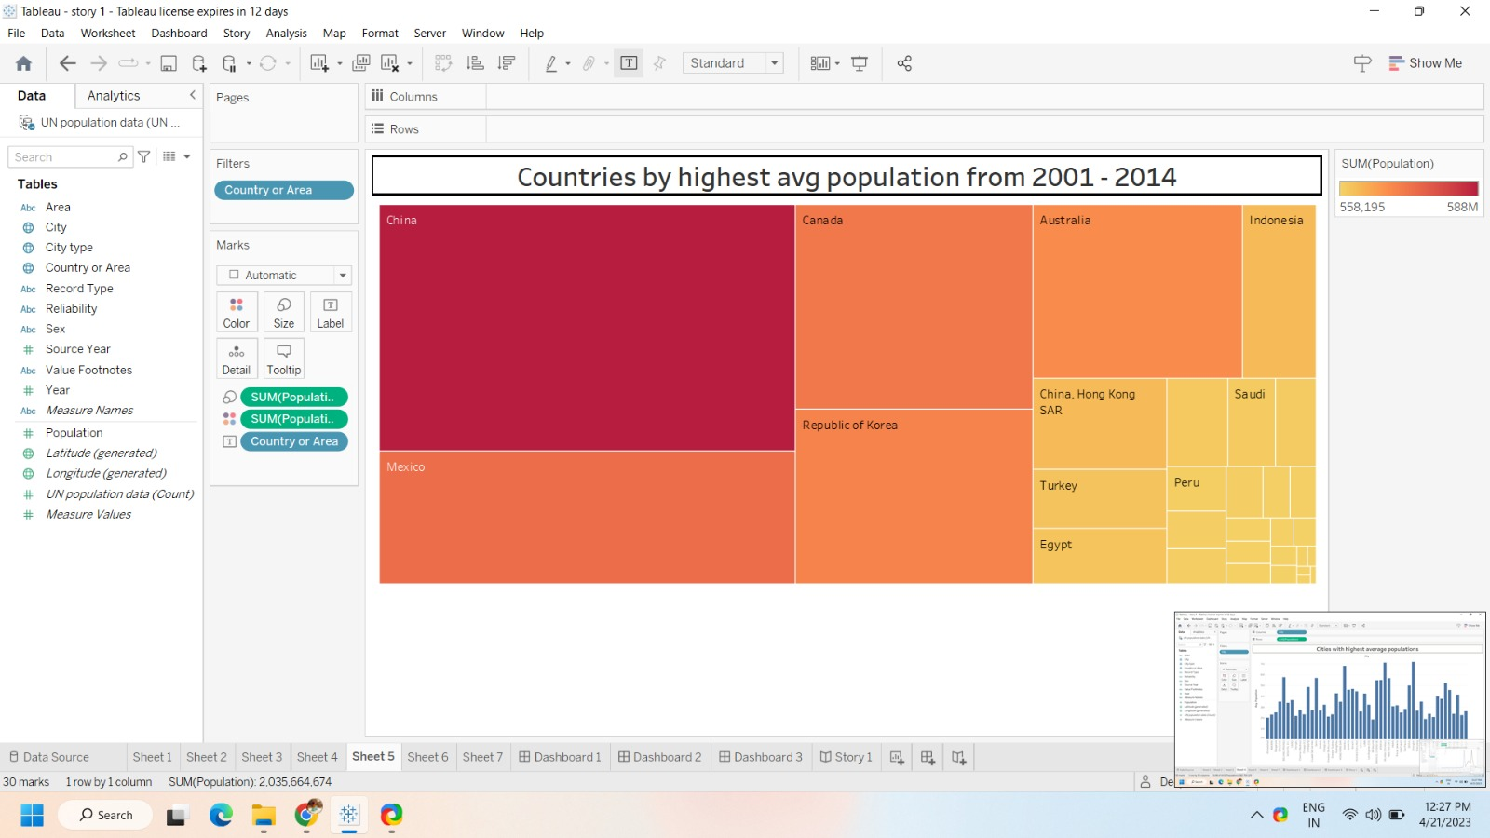

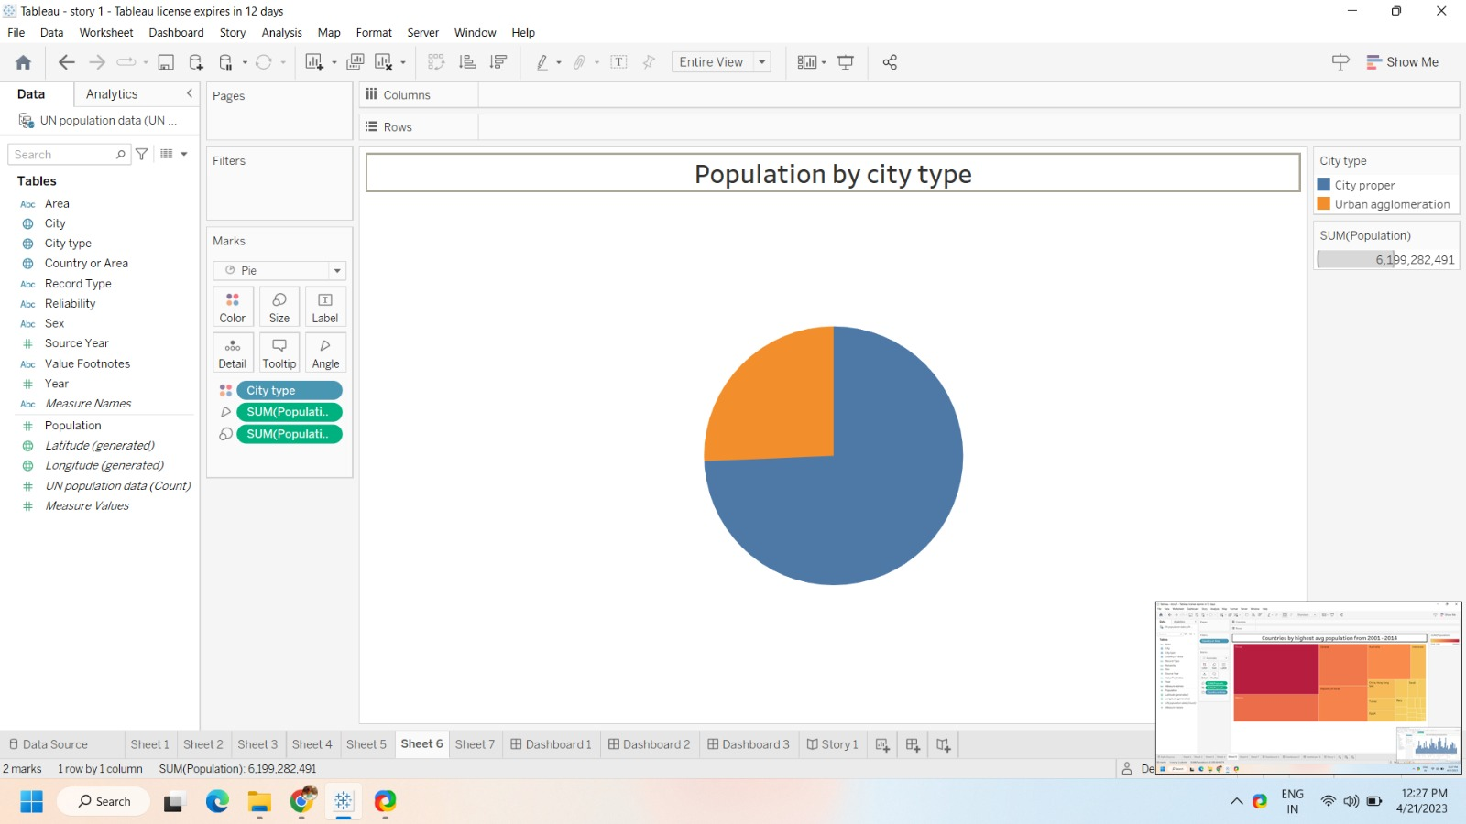

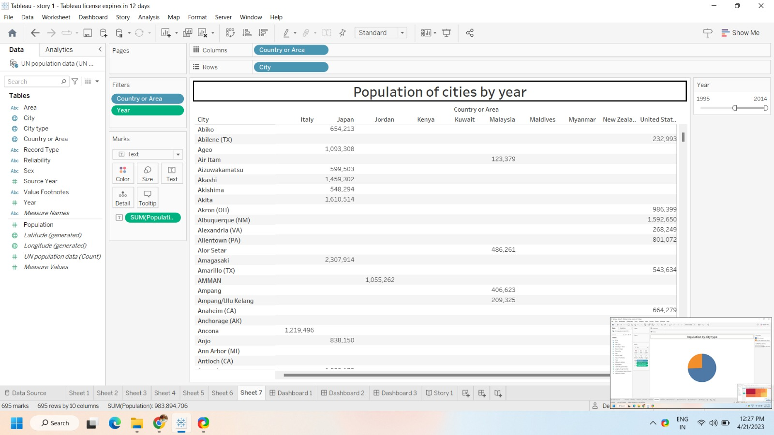

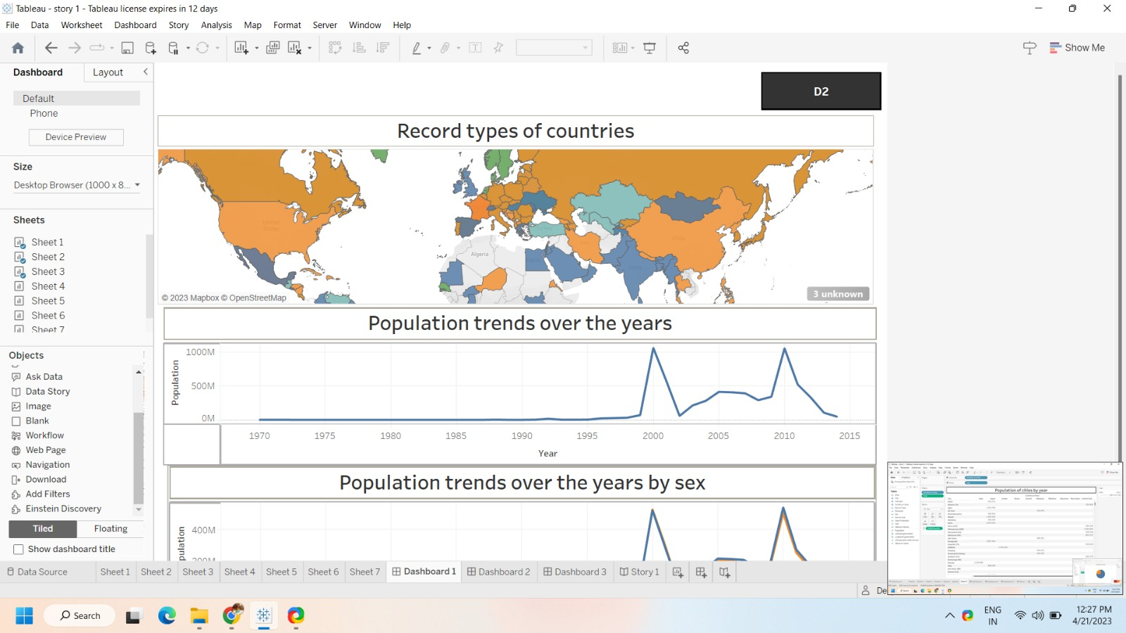

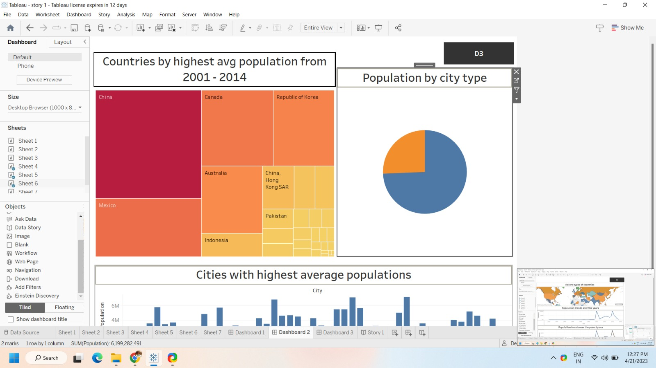

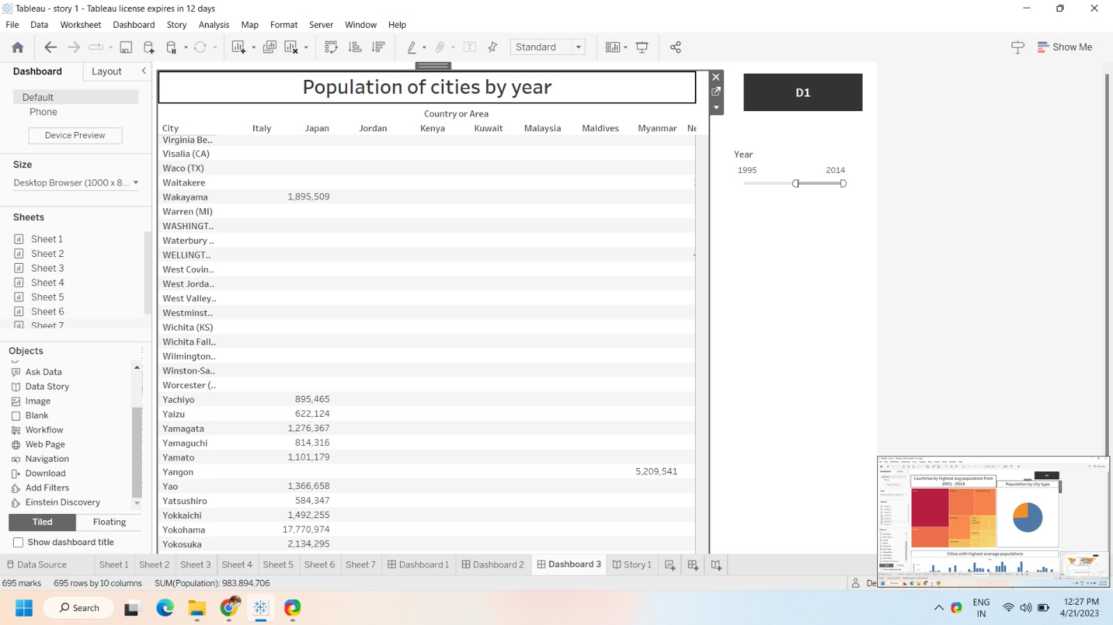

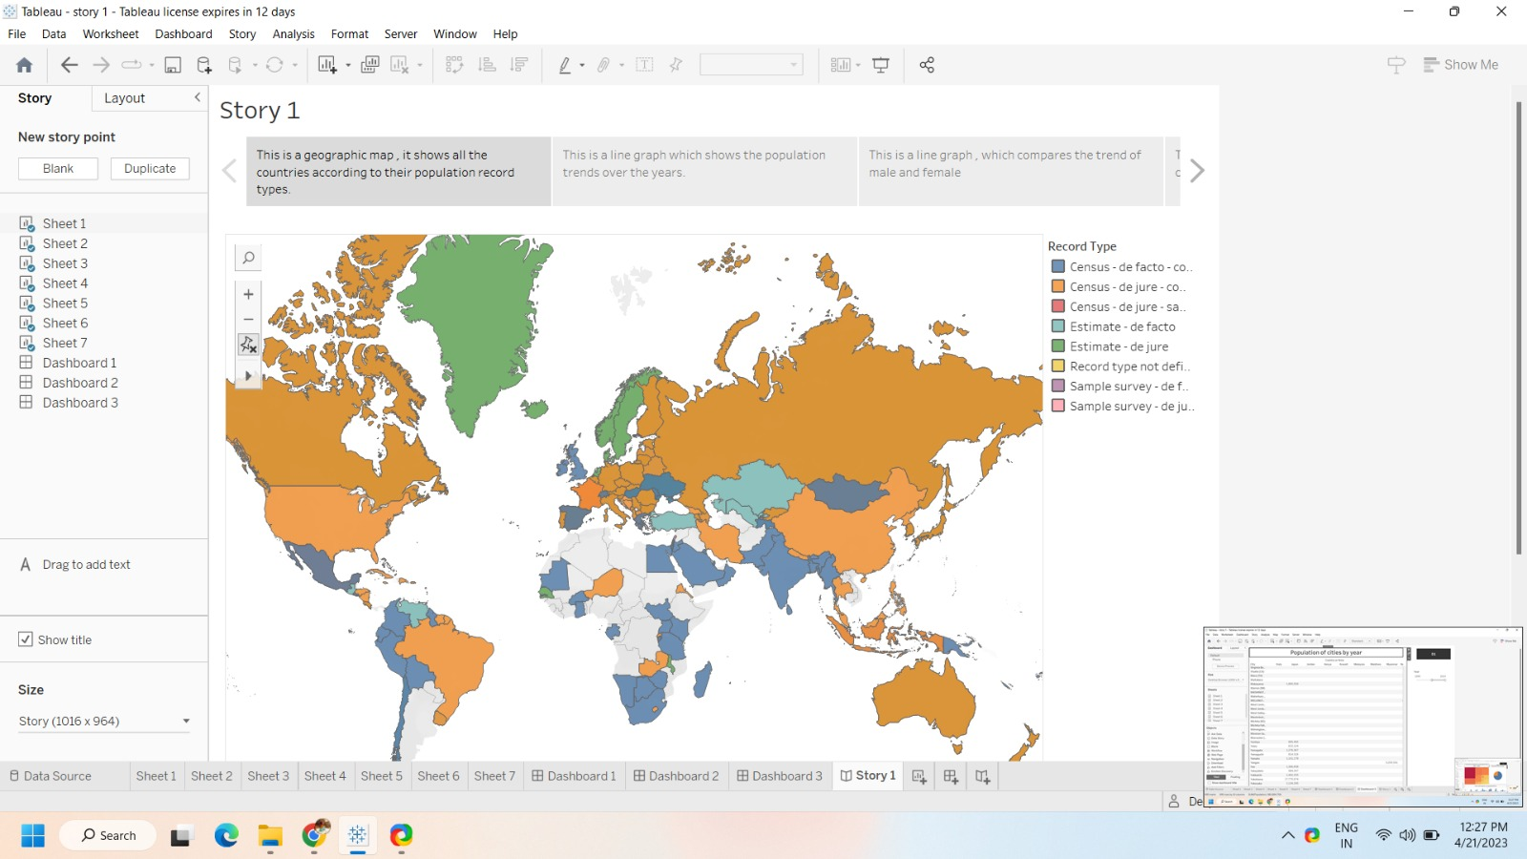

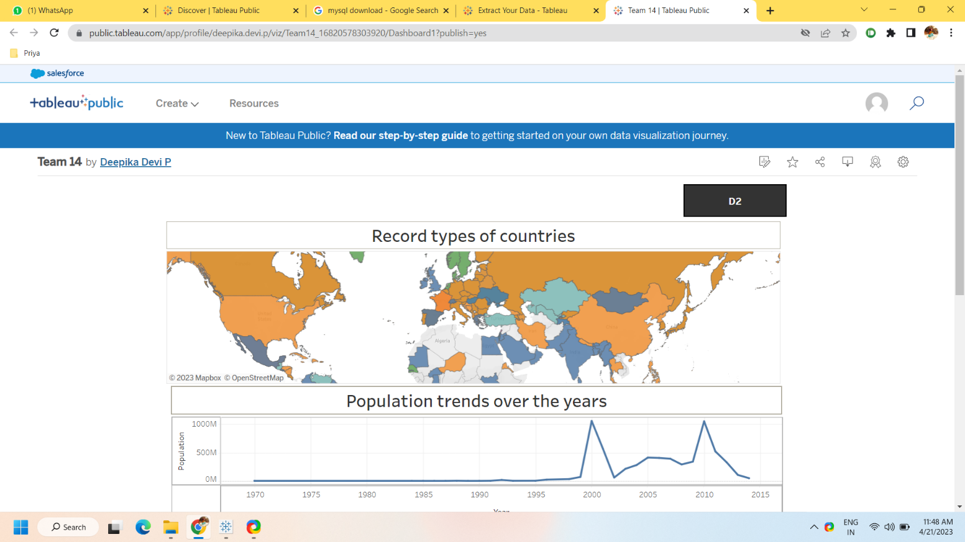

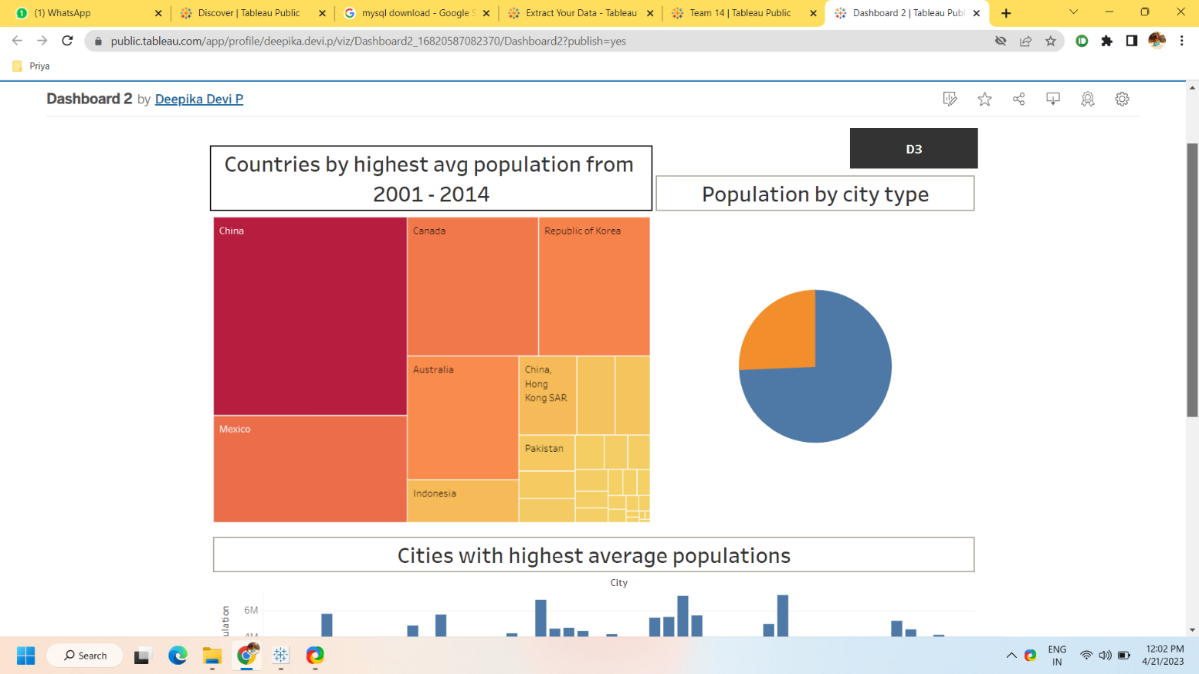

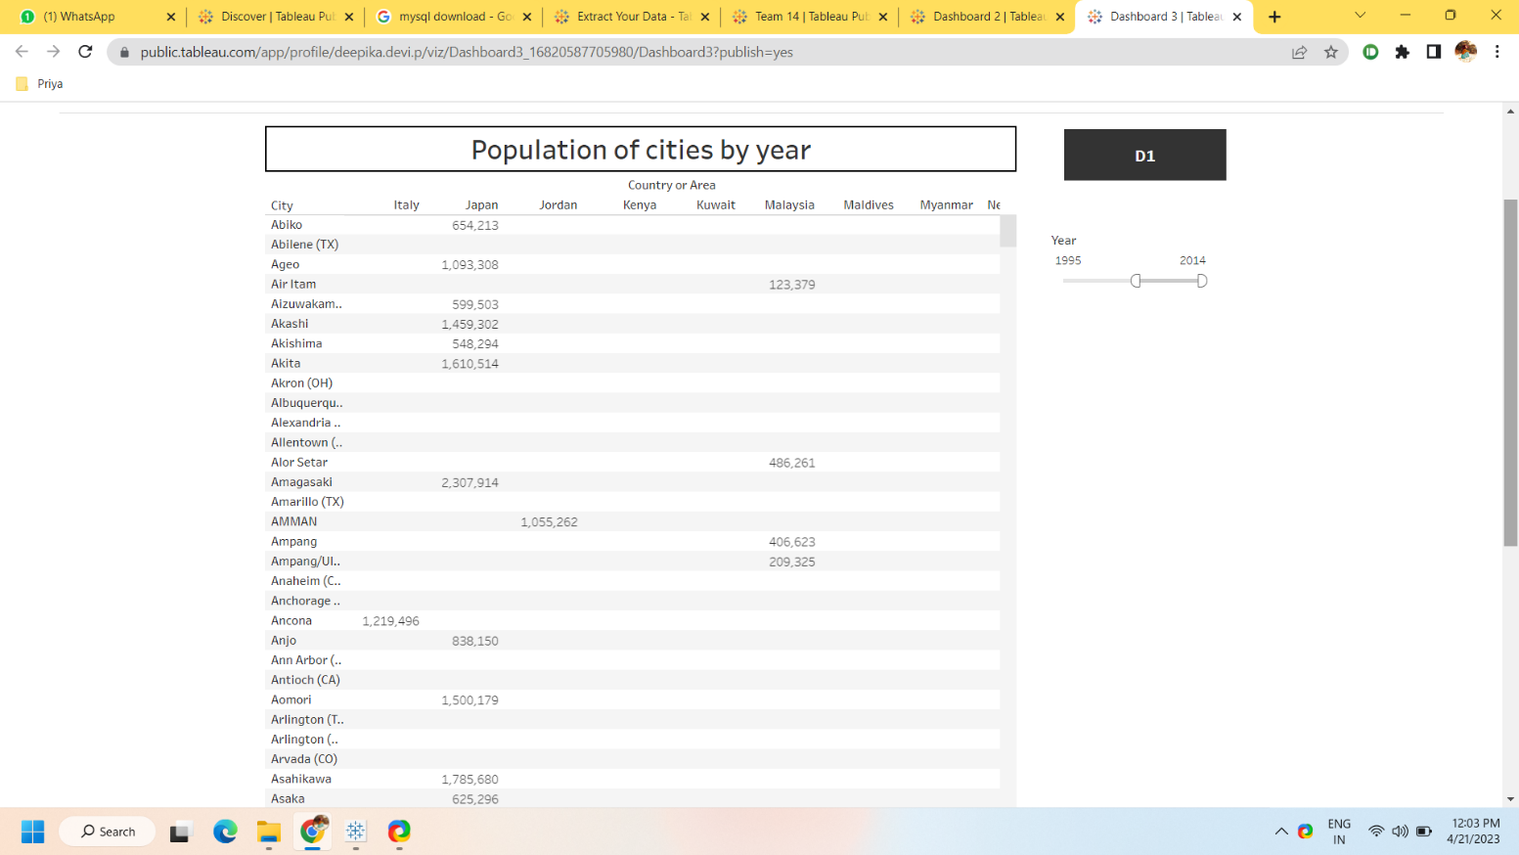

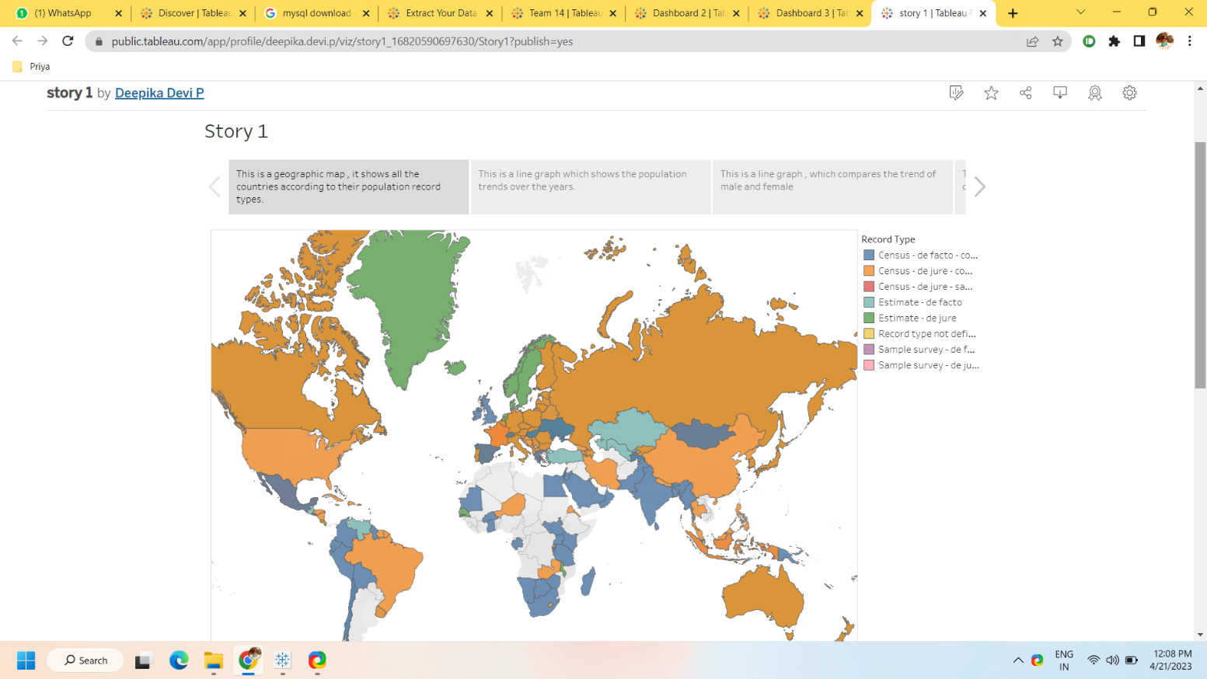

4 Trailhead Profile Public URL

Team Lead - <https://trailblazer.me/id/deepikadevi>

Team Member 1 – <https://trailblazer.me/id/jayapriya17>

Team Member 2 – <https://trailblazer.me/id/karthikasree-22>

Team Member 3 – <https://trailblazer.me/id/vallrasu7>

5 Advantage and Disadvantage

Several advantages, including :

* Understanding cultural diversity
* Identifying commonalities
* Encouraging collaboration
* Facilitating trade and commerce
* Enhancing communication

Potential disadvantages, including:

* Loss of cultural identity
* Unequal distribution of resources
* Spread of disease
* Environmental degradation.
* Political tensions

6 Applications

Some of the most effective and widely used methods include:

Education: Providing education to both men and women can help to reduce population growth. Educated women tend to have fewer children and delay childbearing, which can help to reduce population growth.

Family Planning: Providing access to family planning methods such as contraception, sterilization, and abortion can help to reduce unwanted pregnancies and reduce population growth.

Economic development: Improving the economic conditions of a country can lead to a reduction in population growth. As people become more affluent, they tend to have fewer children.

Health care: Improving health care services, especially maternal and child health care, can reduce infant and child mortality rates. This can lead to a reduction in population growth as parents will have fewer children to compensate for the high mortality rate.

Incentives: Providing incentives such as tax breaks, subsidies, or other financial rewards to families that have fewer children can help to reduce population growth.

Migration: Encouraging people to migrate from overpopulated areas to less populated areas can help to reduce the population density and alleviate pressure on resources.

Top of Form

Bottom of Form

1. Conclusion

The conclusion on population growth is a complex topic with varying perspectives and opinions. However, here are some key points to consider:

1. The world population continues to grow at a rapid pace, with the United Nations projecting it to reach 9.7 billion by 2050.

2. This growth has significant impacts on the environment, including climate change, deforestation, and loss of biodiversity.

3. The impact of population growth on resources such as food, water, and energy is also a major concern, especially in developing countries where the population growth rate is the highest.

4. Family planning, education, and access to healthcare are important factors that can help to slow down population growth.

5. Sustainable development and effective policies that address the challenges of population growth are necessary for the long-term well-being of the planet and its inhabitants.

Overall, population growth is a critical issue that requires a comprehensive and collaborative effort from individuals, communities, and governments to address its impacts and ensure a sustainable future for all.

8 Future Scope

1. Higher taxation of married couple who have few children.
2. Politician imploring the populace to have a bigger family.
3. Enhancement depends on the natural increase of birth and death rate.
4. By improving the agricultural productivity ,medical advancement and sanitation that can reduce the mortality rate and increases the population growth.
5. Policies that can improve the population .
6. Decreased biodiversity will rise the population growth.